The English language belongs to the West Germanic branch of the Indo-European family of languages. The closest undoubted living relatives of English are Scots and Frisian. Frisian is a language spoken by approximately half a million people in the Dutch province of Friesland, in nearby areas of Germany, and on a few islands in the North Sea.
The history of the English language has traditionally been divided into three main periods: Old English (450-1100 AD), Middle English (1100-circa 1500 AD) and Modern English (since 1500). Over the centuries, the English language has been influenced by a number of other languages.
Old English (450 - 1100 AD): During the 5th Century AD three Germanic tribes (Saxons, Angles, and Jutes) came to the British Isles from various parts of northwest Germany as well as Denmark. These tribes were warlike and pushed out most of the original, Celtic-speaking inhabitants from England into Scotland, Wales, and Cornwall. One group migrated to the Brittany Coast of France where their descendants still speak the Celtic Language of Breton today.
Through the years, the Saxons, Angles and Jutes mixed their different Germanic dialects. This group of dialects forms what linguists refer to as Old English or Anglo-Saxon. The word "English" was in Old English "Englisc", and that comes from the name of the Angles. The Angles were named from Engle, their land of origin.
Before the Saxons the language spoken in what is now England was a mixture of Latin and various Celtic languages which were spoken before the Romans came to Britain (54-5BC). The Romans brought Latin to Britain, which was part of the Roman Empire for over 400 years. Many of the words passed on from this era are those coined by Roman merchants and soldiers. These include win (wine), candel (candle), belt (belt), weall (wall).
The influence of Celtic upon Old English was slight. In fact, very few Celtic words have lived on in the English language. But many of place and river names have Celtic origins: Kent, York, Dover, Cumberland, Thames, Avon, Trent, Severn.
The arrival of St. Augustine in 597 and the introduction of Christianity into Saxon England brought more Latin words into the English language. They were mostly concerned with the naming of Church dignitaries, ceremonies, etc. Some, such as church, bishop, baptism, monk, eucharist and presbyter came indirectly through Latin from the Greek.
Around 878 AD Danes and Norsemen, also called Vikings, invaded the country and English got many Norse words into the language, particularly in the north of England. The Vikings, being Scandinavian, spoke a language (Old Norse) which, in origin at least, was just as Germanic as Old English.
Words derived from Norse include: sky, egg, cake, skin, leg, window (wind eye), husband, fellow, skill, anger, flat, odd, ugly, get, give, take, raise, call, die, they, their, them.
Several written works have survived from the Old English period. The most famous is a heroic epic poem called "Beowulf". It is the oldest known English poem and it is notable for its length - 3,183 lines. Experts say "Beowulf" was written in Britain more than one thousand years ago. The name of the person who wrote it is unknown.
Middle English (1100-circa 1500 AD): After William the Conqueror, the Duke of Normandy, invaded and conquered England in 1066 AD with his armies and became king, he brought his nobles, who spoke French, to be the new government. The Old French took over as the language of the court, administration, and culture. Latin was mostly used for written language, especially that of the Church. Meanwhile, The English language, as the language of the now lower class, was considered a vulgar tongue.
By about 1200, England and France had split. English changed a lot, because it was mostly being spoken instead of written for about 300 years. The use of Old English came back, but with many French words added. This language is called Middle English. Most of the words embedded in the English vocabulary are words of power, such as crown, castle, court, parliament, army, mansion, gown, beauty, banquet, art, poet, romance, duke, servant, peasant, traitor and governor.
Because the English underclass cooked for the Norman upper class, the words for most domestic animals are English (ox, cow, calf, sheep, swine, deer) while the words for the meats derived from them are French (beef, veal, mutton, pork, bacon, venison).
The Middle English is also characterized for the beginning of the Great Vowel Shift. It was a massive sound change affecting the long vowels of English. Basically, the long vowels shifted upwards; that is, a vowel that used to be pronounced in one place in the mouth would be pronounced in a different place, higher up in the mouth. The Great Vowel Shift occurred during the fifteenth to eighteenth centuries.
The most famous example of Middle English is Chaucer's "The Canterbury Tales", a collection of stories about a group of thirty people who travel as pilgrims to Canterbury, England. The portraits that he paints in his Tales give us an idea of what life was like in fourteenth century England.
Modern English (1500 to the present): Modern English developed after William Caxton established his printing press at Westminster Abbey in 1476. Johann Gutenberg invented the printing press in Germany around 1450, but Caxton set up England's first press. The Bible and some valuable manuscripts were printed. The invention of the printing press made books available to more people. The books became cheaper and more people learned to read. Printing also brought standardization to English.
By the time of Shakespeare's writings (1592-1616), the language had become clearly recognizable as Modern English. There were three big developments in the world at the beginning of Modern English period: the Renaissance, the Industrial Revolution, and the British Colonialism.
It was during the English Renaissance that most of the words from Greek and Latin entered English. This period in English cultural history (early 16th century to the early 17th century) is sometimes referred to as "the age of Shakespeare" or "the Elizabethan era", taking the name of the English Renaissance's most famous author and most important monarch, respectively. During the reign of Queen Elizabeth I there was an explosion of culture in the form of support of the arts, popularization of the printing press, and massive amounts of sea travel.
England began the Industrial Revolution (18th century) and this had also an effect on the development of the language as new words had to be invented or existing ones modified to cope with the rapid changes in technology. New technical words were added to the vocabulary as inventors designed various products and machinery. These words were named after the inventor or given the name of their choice (trains, engine, pulleys, combustion, electricity, telephone, telegraph, camera etc).
Britain was an Empire for 200 years between the 18th and 20th centuries and English language continued to change as the British Empire moved across the world - to the USA, Australia, New Zealand, India, Asia and Africa. They sent people to settle and live in their conquered places and as settlers interacted with natives, new words were added to the English vocabulary. For example, 'kangaroo' and 'boomerang' are native Australian Aborigine words, 'juggernaut' and 'turban' came from India.
English continues to change and develop, with hundreds of new words arriving every year. But even with all the borrowings from many other languages the heart of the English language remains the Anglo-Saxon of Old English. The grammar of English is also distinctly Germanic - three genders (he, she and it) and a simple set of verb tenses.
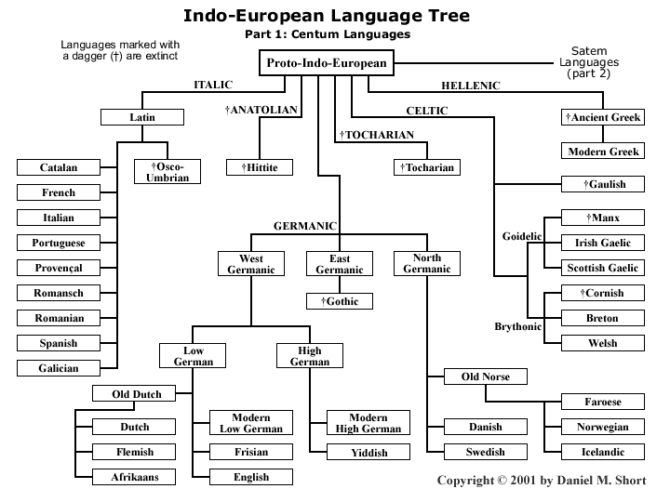

ACTIVIDAD 1
- Recorrer el texto hasta el final, e identificar el párrafo relacionado con la imagen incluida al final.
- Identificar el párrafo que anuncia el Tema General del texto marcando con TG.
- Marcar el párrafo que introduce la organización del texto. PI (párrafo introductorio).
- Identificar el tipo de texto y la estructura que predomina (narrativo, descriptivo, argumentativo, instructivo).
- Analizar la siguiente tabla y compararla con el contenido del siguiente párrafo.
The history of the English language has traditionally been divided into three main periods: Old English (450-1100 AD), Middle English (1100-circa 1500 AD) and Modern English (since 1500). Over the centuries, the English language has been influenced by a number of other languages.
¿Por qué hay más espacios para períodos y varias subdivisiones en algunos?
- Utilizando las cifras, la puntuación, las palabras transparentes y las conocidas, y el orden de la información trabajado en el TP anterior, completar.
- Identificar los párrafos que comienzan con una referencia temporal y marcarlo con RT. Subrayar el tema (sujeto) de la oración.
PERIODO | HECHO | IDIOMA | PALABRAS
Old English (450-1100 AD)
Middle English (1100-circa 1500 AD)
Modern English (since 1500)
- Unir con flechas
Expresión | Concepto | Significado
By about | Momento de inicio  Período  Momento aproximado  Anterioridad | Desde
By the time of | Momento de inicio  Período  Momento aproximado  Anterioridad | Alrededor de
Around | Momento de inicio  Período  Momento aproximado  Anterioridad | Para … (fecha )
Before | Momento de inicio  Período  Momento aproximado  Anterioridad | Para (los tiempos de..)
Through the years | Momento de inicio  Período  Momento aproximado  Anterioridad | A través de
Since | Momento de inicio  Período  Momento aproximado  Anterioridad | Antes
During | Momento de inicio  Período  Momento aproximado  Anterioridad | Durante

- Releer los siguientes conceptos e identificar el Tema (sujeto) de cada oración y completar.
- England began the Industrial Revolution (18th century) and this had also an effect on the development of the language…
- Britain was an Empire for 200 years between the 18th and 20th centuries and English language continued to change…
- Through the years, the Saxons, Angles and Jutes mixed…
- The arrival of St. Augustine in 597 and the introduction of Christianity into Saxon England brought…
- During the 5th Century AD three Germanic tribes (Saxons, Angles, and Jutes) came…
- Around 878 AD Danes and Norsemen, also called Vikings, invaded…
- Temas con una sola palabra. Letras ….
- Temas con más palabra. Letras ….
- La palabra “and”: ¿+ o -? … ¿Elementos = o =? …
- La función de “of”, “into” en d. es …
- En e y f, “(…)” y “,…,” la función es = o =?
- En f, “also” ¿+ o -? …
- Releer los siguientes conceptos e identificar la función de la palabra “and” y completar
- English continues to change and develop…
- England began the Industrial Revolution (18th century) and this had also an effect on the development of the language…

¿+ o -? …
- Identificar las diferencias de tiempo en los siguientes conceptos.
- English continues to change and develop, with hundreds of new words arriving every year.
- England began the Industrial Revolution (18th century) and this had also an effect on the development of the language…

Presente: Letra …. Pasado: Letra….
- Subrayar los verbos y completar
- Modern English developed after William Caxton established his printing press at Westminster Abbey in 1476. Johann Gutenberg invented the printing press in Germany around 1450, but Caxton set up England's first press.
- By the time of Shakespeare's writings (1592-1616), the language had become clearly recognizable as Modern English.
- New technical words were added to the vocabulary
- Pasado: Letras ….
- Un hecho pasado anterior a otros mencionados: Letra….
- Un hecho en el pasado en que el Tema (sujeto) no ejecuta sino recibe la acción del verbo: Letra….
- Completar con los verbos que derivan de:
- Bring …………………
- Invent …………………
- Come…………………
- Add …………………
- Establish …………………
- Become …………………
- Begin …………………
- Have …………………

Algunos están repetidos.

